**ASSESSMENT AND INTERNAL VERIFICATION FRONT SHEET (Individual Criteria)**

|  |  |  |  |  |  |  |
| --- | --- | --- | --- | --- | --- | --- |
| Course Title | Advanced Diploma in IT (MQF Level 4) | | | Lecturer Name & Surname |  | |
| Unit Number & Title | | **ITSFT-406-1506–Client-Side Scripting** | | | | |
| Assignment Number, Title / Type | | **02, Client-Side Scripting Project (Home Assignment)** | | | | |
| Date Set | | **05-12-2022** | **Deadline Date** | **11-01-2023** | | |
| Student Name |  | | **ID Number** |  | **Class / Group** |  |

|  |  |  |
| --- | --- | --- |
| Assessment Criteria | Maximum Mark | Mark Achieved |
| *KU1.3: Describe the methodology used in a supporting technology* | 5 |  |
| *KU1.4: Identify advantages of supporting technologies* | 5 |  |
| *KU1.5: Describe the necessity for responsive design* | 5 |  |
| *KU1.6: Explain the need for validation of input on the client* | 5 |  |
| *KU3.3: Examine and ensure form validation is carried out on the client* | 5 |  |
| *KU3.4: Test, log, identify, and rectify errors ensuring testing using a number of browsers* | 5 |  |
| *AA2.3: Use event handlers to enhance the user experience* | 7 |  |
| *AA2.5: Apply scripts to validate user input and to improve a design element* | 7 |  |
| *AA2.6: Apply scripts to improve image presentation* | 7 |  |
| *SE3.1: Create an interactive web application making use of scripting techniques to enhance functionality* | 10 |  |
| *SE3.2: Create a dynamic navigation system* | 10 |  |
| Total Mark | **71** |  |

|  |
| --- |
| **Notes to Students:** |
| * This assignment brief has been approved and released by the Internal Verifier through Classter. * Assessment marks and feedback by the lecturer will be available online via Classter (<Http://mcast.classter.com>) following release by the Internal Verifier * Students submitting their assignment on VLE/Turnitin will be requested to confirm online the following statements:   **Student’s declaration prior to handing-in of assignment**   * I certify that the work submitted for this assignment is my own and that I have read and understood the respective Plagiarism Policy   **Student’s declaration on assessment special arrangements**   * I certify that adequate support was given to me during the assignment through the Institute and/or the Inclusive Education Unit. * I declare that I refused the special support offered by the Institute. |

Advanced Diploma in IT (MQF Level 4)

ITSFT-406-1506: Client-Side Scripting

**Home Assignment: Client-Side Scripting Project**

**Assignment Guidelines**

* This assignment is a **Home Assignment** and should be strictly completed by **11th January 2023**.
* Fill in the assignment **cover sheet completely**. The student’s assignment cover sheet should be attached to the project being submitted. Note that assignments handed in without the cover sheet will be considered as ***Not Submitted***.
* Answer all the questions in a structured document and relevant programs/files.
* Highlight clearly the Criteria Number/Question Number and your answer in your work.
* Submission method: **soft copy only** through **VLE** (more instructions will be given by your lecturer).
* **Plagiarism is strictly prohibited. Proper references must be used**. **Copying** will be **penalized** in line with the College’s disciplinary procedures.
* **Individual interviews** may be held and hence the achievement of marks will depend on the outcome of the interview accordingly.

Using a web code editor (such as *Brackets* or *Visual Studio Code*), you are to create a Web Application for a ***scenario of your choice*** using *HTML, CSS, JavaScript* and *Bootstrap* accordingly.

The following web pages are required:

* Home page
* Gallery page
* Contact Us page

The required functionalities to be included in the above pages will be explained in the coming questions and therefore it is suggested that you read the whole assignment before starting any of the questions.

***Question 1 (KU1.3 – 5marks; KU1.4 – 5marks):***

**Proposal:**

1. You are to write a paragraph describing the scenario/topic you have chosen about which you are going to create your web application.
2. You are also to create a proper design of your **home page** clearly showing elements and components (labels, inputs, button, etc) upon which your JavaScript functionality will work.

***Note:*** You have **5 days** from the assignment issue date to submit your proposal document (including both the paragraph and design) to your lecturer through **VLE** submission. Your lecturer will instruct you accordingly.

***Question 2 (AA2.3 – 7marks; KU1.6 – 5marks; AA2.5 – 7marks):*** The Home page must include some informative contents such as a welcoming title, banner and so on, and *at least* 4 user inputs for your custom JavaScript functionality.

**Note:** *at least 1 of the inputs must be an input field (number or text); and all inputs must not be of the same type.*

Below is a generic sample of such input components:  
  
When the user makes the necessary inputs and clicks the button, the ***onclick*** event must trigger a *JavaScript* function called ***ValidateAndCalculate()***. You are to code the ***ValidateAndCalculate()*** with the following functionalities:

* Check that all the inputs are valid (not left blank, valid numeric values entered in a numeric input, correct value range, etc). The inputs must be parsed if necessary. If the inputs are not valid, an error message must be shown such that the user can amend the inputs, such as follows:

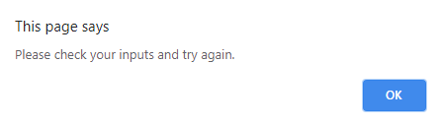

* Once the inputs are valid, the calculated value must be displayed to the user. For example, if a quotation with a Total Price was calculated then something as follows must be shown as a result:

***Question 3 (KU3.3 – 5marks):*** Within the *Contact Us* page you are required to include a *functional* contact form having a *mailto* attribute linked to your email address. A sample layout of the contact form is shown below:

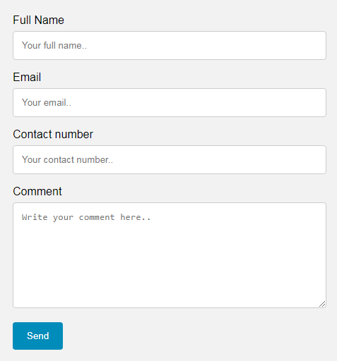

You are required to create a JavaScript function called ***validateForm()***, such that when the user clicks the ***Send*** button, it will check that the user has filled in ALL of the fields, otherwise an error message is displayed and the input fields are highlighted as follows:

***Question 4 (AA2.6 – 7marks; SE3.1 – 10marks):*** Within the *Gallery* page you are required to implement a fully functional Carousel Gallery containing at least 4 images using Bootstrap technology. A sample design including gallery controls (previous image, next image and indicators) is shown below:  
  


***Question 5 (SE3.2 – 10marks):*** All of your web application pages must include a Bootstrap/JavaScript horizontal navigation menu bar, which when viewed on a wide screen device (such as a desktop monitor) it should be as follows:  
  


While when the website pages are then shown on a smaller/narrow screen device (such as smartphone) it should hide all menu items and display a burger button instead:  
  


When clicked, the above burger button should unveil the menu items as shown below:  
  
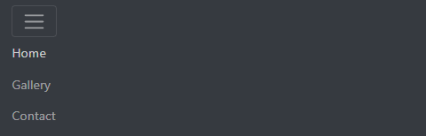

***Question 6 (KU1.5 – 5marks):*** You are to explain what benefits you achieved by using Bootstrap framework in your web application in questions 4 and 5. Moreover, you are to further explain why responsive web design is important and desirable.

***Question 7 (KU3.4 – 5marks):*** Using the below test case template, you are required to test your website’s navigation menu bar/burger button that you have implemented using *Bootstrap/JavaScript* framework. You need to perform and fill in this test case template twice such that the test is carried out using 2 different web browsers of your choice. Note: make sure to include at least 2 screenshots for each browser test.

|  |  |  |  |  |  |
| --- | --- | --- | --- | --- | --- |
| **Project:** | |  | | | |
| **Author:** | |  | | | |
| **Test Case number:** | |  | | | |
| **Test Case Title:** | |  | | | |
| **Test Case Description:** | |  | | | |
| **Steps**  **Performed** | **Expected outcome** | | **Actual**  **outcome** | **Result (Pass/Fail)** | **Further comments** |
|  |  | |  |  |  |

Marking scheme

|  |  |  |  |
| --- | --- | --- | --- |
| Criteria | Marking structure | Maximum mark | Mark Awarded |
| *KU1.3 (Q1a)* | **5 marks** for a proper proposal paragraph describing the scenario/topic chosen by the student. | 5 |  |
| *KU1.4 (Q1b)* | **5 marks** for the created design of your **home page** clearly showing elements and components (labels, inputs, button, etc) upon which your JavaScript functionality will work. | 5 |  |
| *AA2.3 (Q2)* | **1 mark** for correct use of onclick button event handler such that the *ValidateAndCalculatePrice()* function is properly executed  **2 marks** for proper handling/parsing/storage (in variables/arrays) of user inputs (according to the proposed scenario by student)  **4 marks** for proper use of if statement/s leading to result calculation (according to the proposed scenario by student) | 7 |  |
| *KU1.6 (Q2)* | Properly output messages to the user:  **2 marks** for showing a message to the user in case of invalid inputs (according to the proposed scenario by student)  **3 marks** for showing the final output result (according to the proposed scenario by student) | 5 |  |
| *AA2.5 (Q2)* | **7 marks** for validating user inputs (not left blank, valid numeric values entered in a numeric input, correct value range, etc) on homepage using JavaScript and properly accepting only valid inputs (according to the proposed scenario by student) | 7 |  |
| *KU3.3 (Q3)* | **1 mark** for creating the *validateForm()* function and calling it when the user submits the form **1 mark** for each validated field (full name, email, contact number, and comment) including the changed colour style through JavaScript | 5 |  |
| *AA2.6 (Q4)* | **4 marks** for correct implementation of the previous-image and next-image buttons within the Bootstrap Carousel gallery  **3 marks** for correct implementation of the carousel indicators (bottom of carousel) within the Bootstrap Carousel gallery | 7 |  |
| *SE3.1 (Q4)* | **3 marks** for including the necessary Bootstrap and Javascript libraries/files  **7 marks** for creating the fully functional Bootstrap Carousel gallery/slideshow having at least 4 images | 10 |  |
| *SE3.2 (Q5)* | **5 marks** for creating the actual navigation menu bar using Bootstrap/JavaScript **5 marks** for making the navigation menu burger act in a responsive manner on small screen sizes by hiding its menu items under a burger button, which when clicked unveils all of the menu items again | 10 |  |
| *KU1.5 (Q6)* | **2.5 marks** for explaining what benefits you achieved by using Bootstrap in questions 4 and 5 **2.5 marks** for further explaining why responsive web design is important and desirable. | 5 |  |
| *KU3.4 (Q7)* | **2.5 marks** per completely correct test case in a different browser | 5 |  |

**Total Marks (out of 71): ______**